**Project Output Screenshots:**

1. Console: Console with all menus for the user to choose from the options.

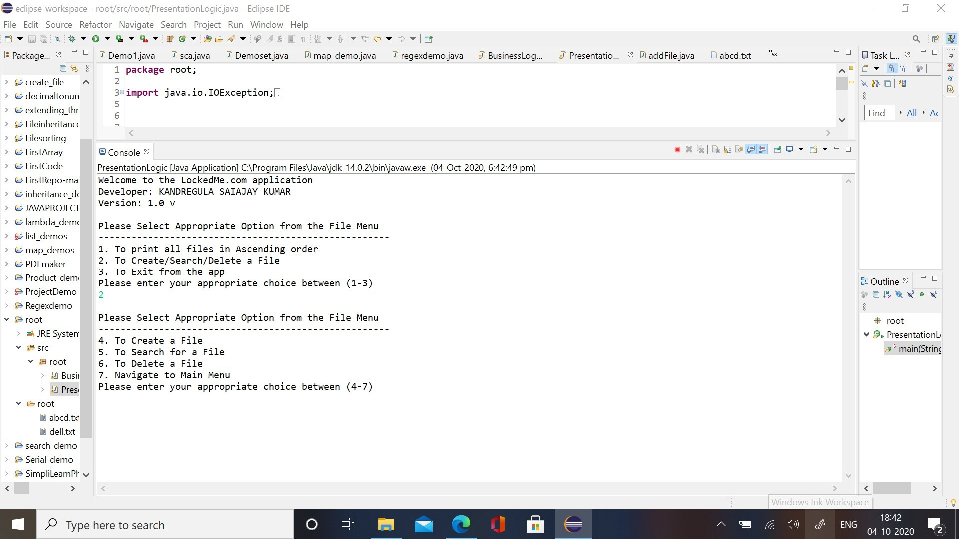

1. Create File:
2. To create a new file.

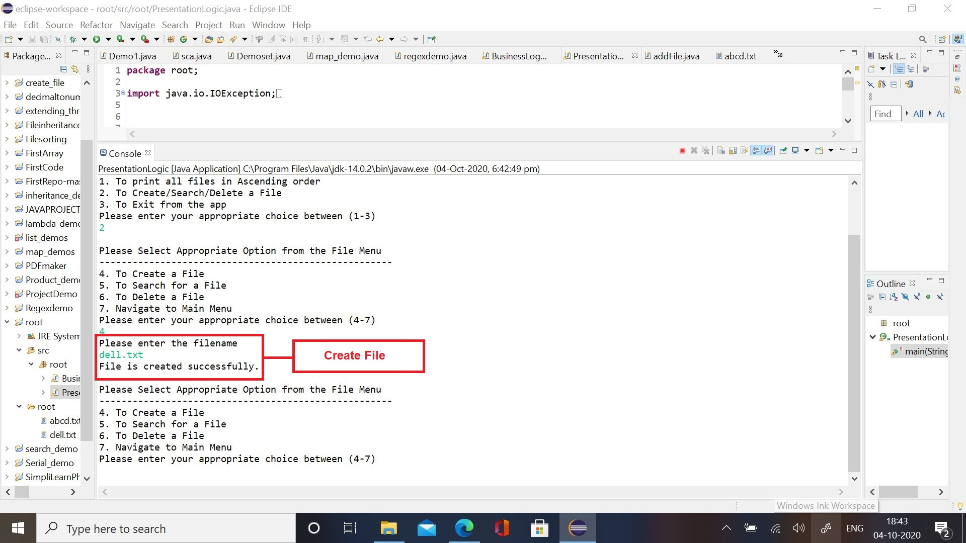

1. If file already exists in the directory:

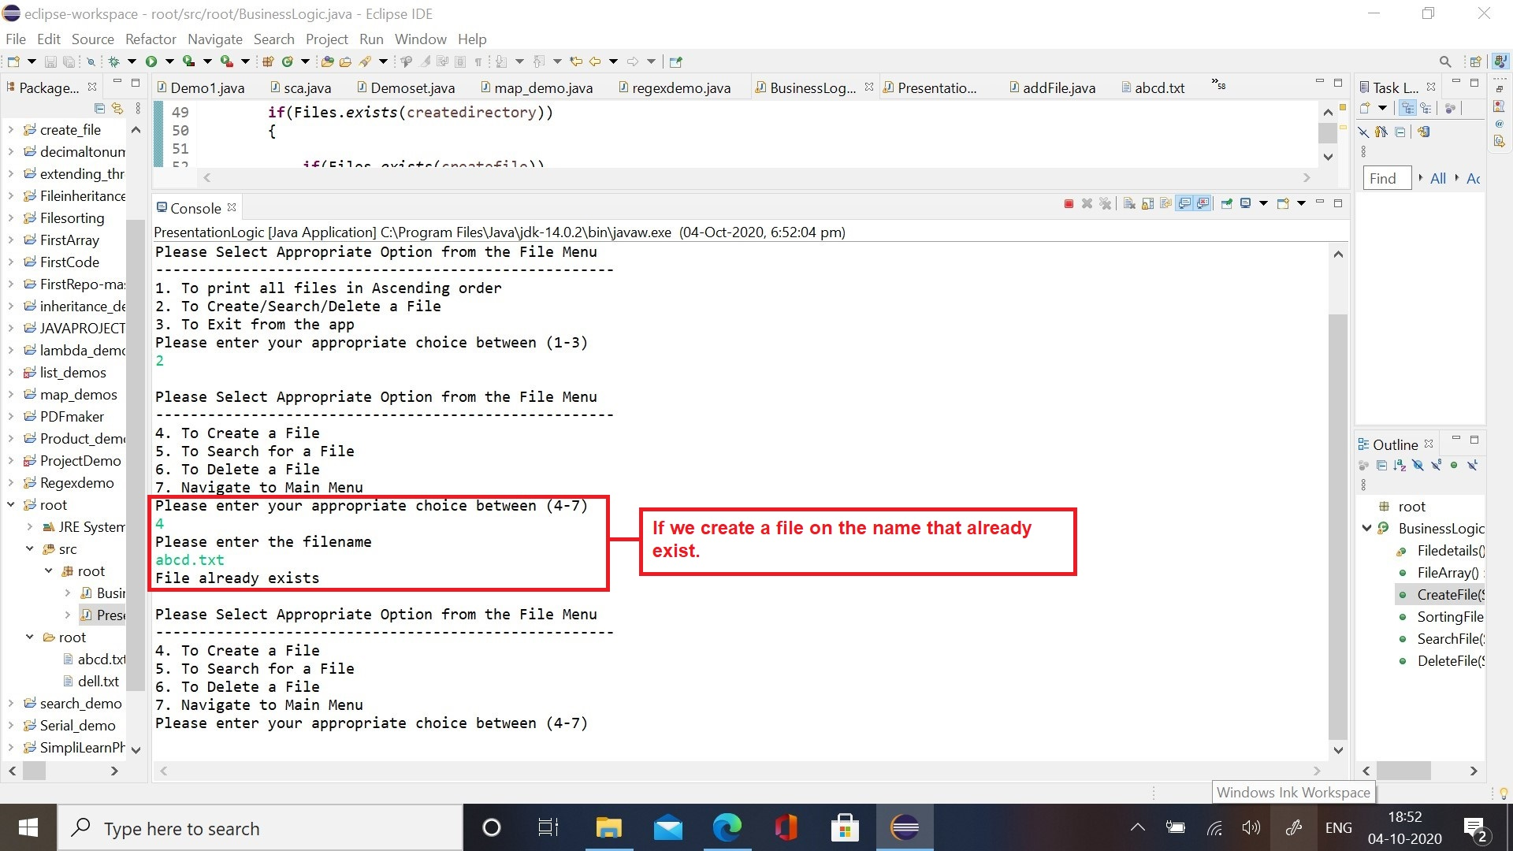

1. Search File:
2. Search for a file that exists in the directory:

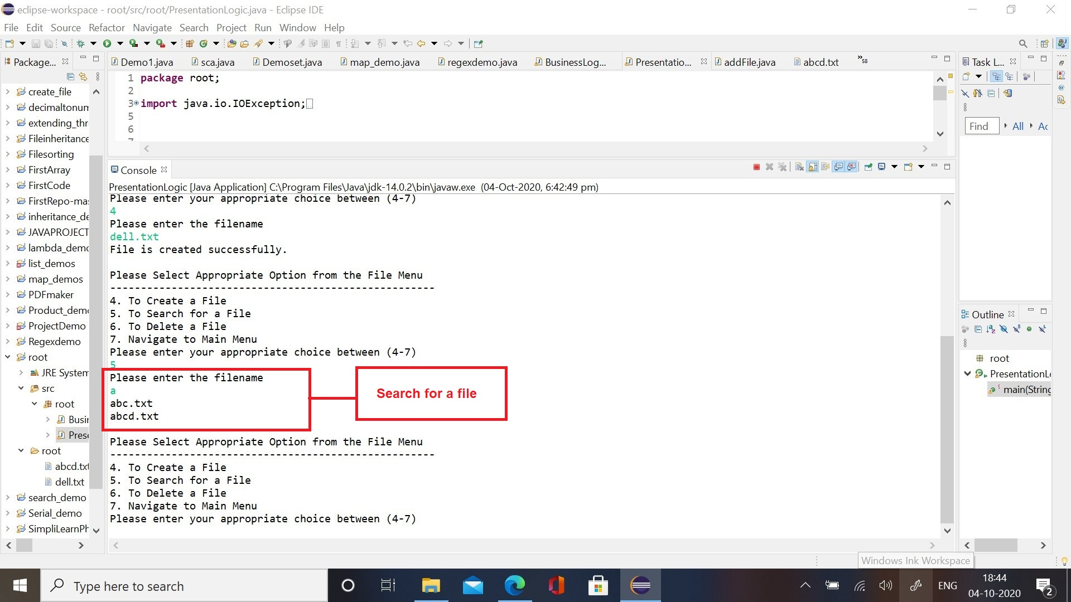

1. Search for a file that does not exist in the directory:

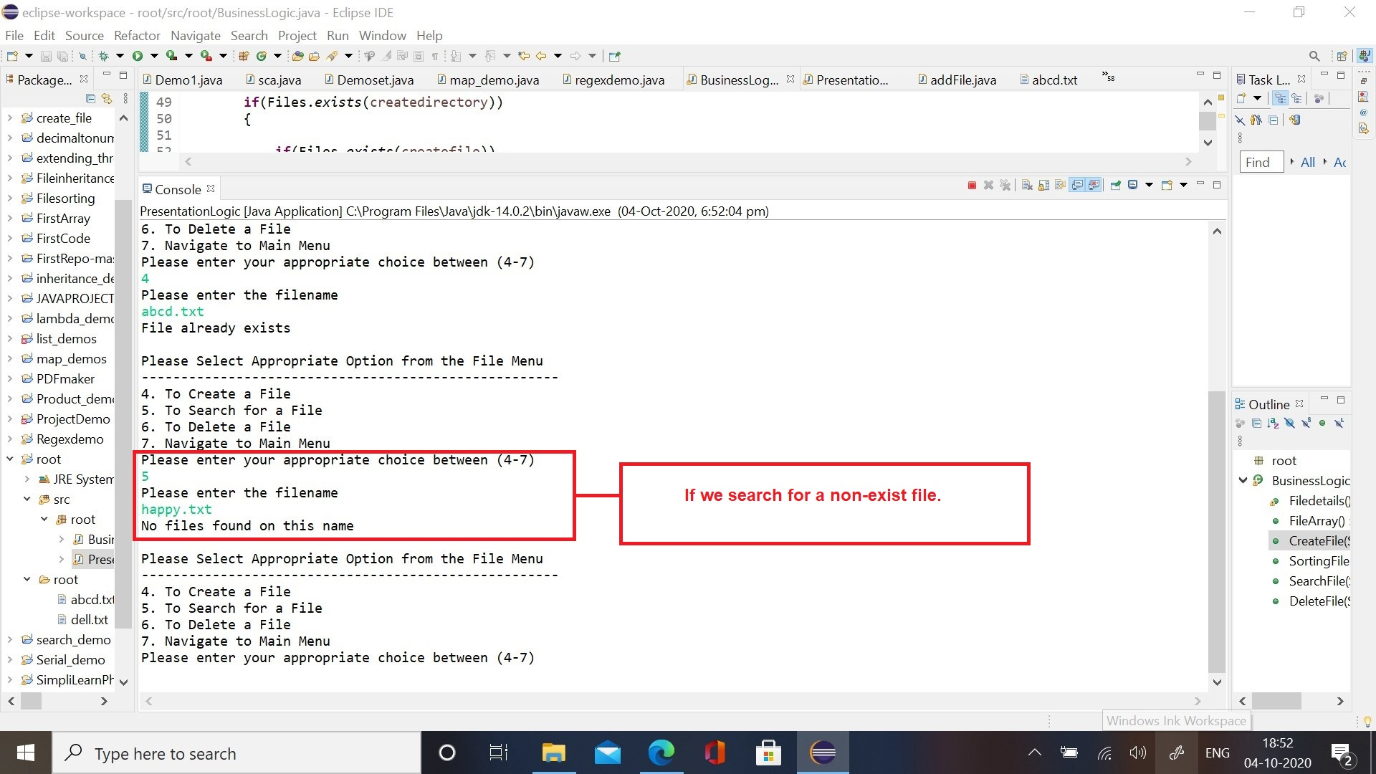

1. Delete File:
2. Delete a file that exists in the directory;

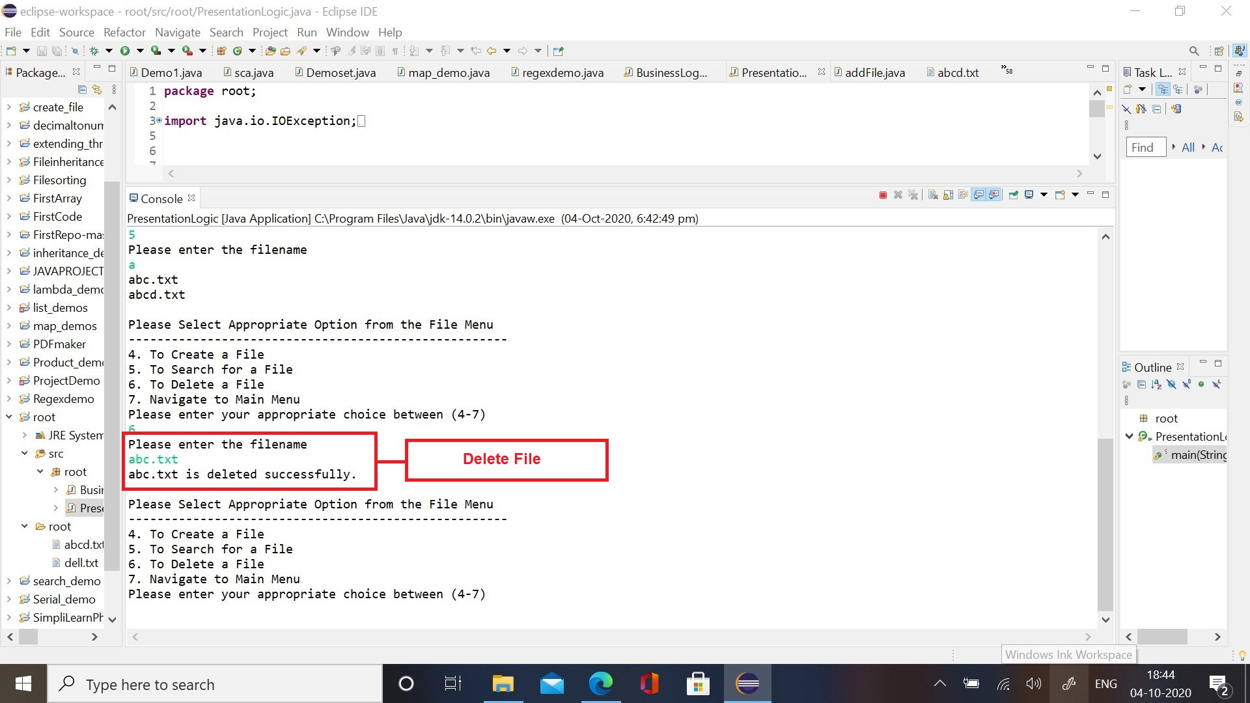

1. Delete a file that does not exist in the directory:

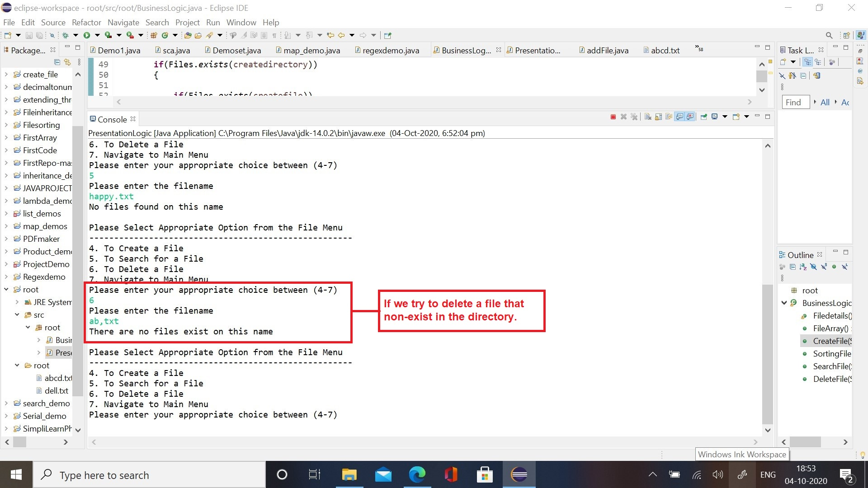

1. Sort File: Sort the files in ascending order in the directory

